NAMA : MUHAMMAD RIFKY ALFAREZ

NIM : 201851041

KELAS : F

1. Aturan Bisnins/Asumsi
   1. tbl_pegawai memiliki nip, sementara tbl_matrik hanya memiliki satu nip setiap pegawai
   2. tbl_user hanya untuk user login
2. ERD

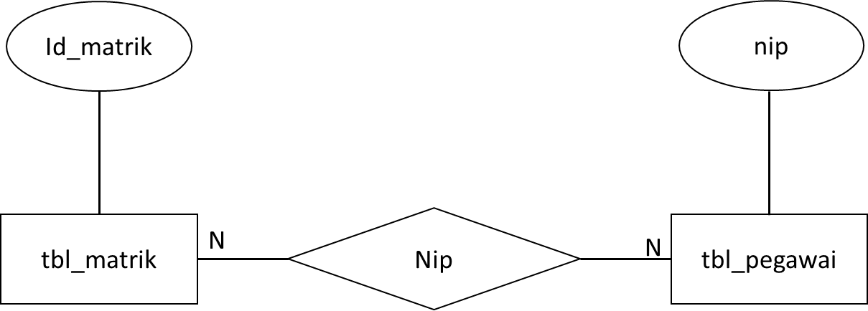

1. Skema Tabel

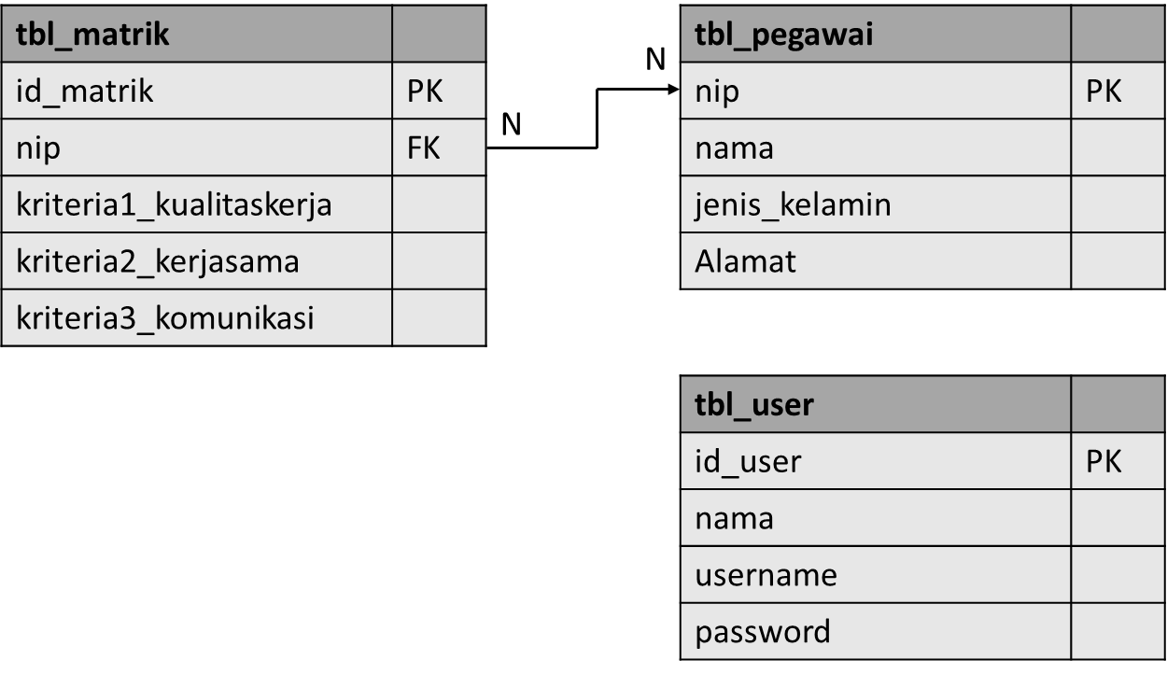

1. Struktur Tabel
   1. tbl_matrik

|  |  |  |  |  |
| --- | --- | --- | --- | --- |
| No | Nama Field | Tipe | Constraint | Keterangan |
| 1 | Id_matrik | Int(11) | Not Null | Primary key tabel tbl_matrik |
| 2 | Nip | Int(11) | Not Null | Mengambil nip dari tabel tbl_pegawai |
| 3 | Kriteria1_kualitaskerja | Int(4) | Not Null | Kriteria 1 kuaitas kerja |
| 4 | Kriteria2_kerjasam | Int(4) | Not Null | Kriteria 2 Kerjasama |
| 5 | Kriteria3_komunikasi | int(4) | Not Null | Kriteria 3 komunikasi |

* 1. tbl_pegawai

|  |  |  |  |  |
| --- | --- | --- | --- | --- |
| No | Nama Field | Tipe | Constraint | Keterangan |
| 1 | Nip | Int(11) | Not Null | Primary key tabel tbl_pegawai |
| 2 | Nama | Varchar(35) | Not Null | Nama pegawai administrasi |
| 3 | Jenis_kelamin | Varchar(15) | Not Null | Jenis Kelamin pegawai administrasi |
| 4 | Alamat | Text | Not Null | Alamat pegawai administrasi |

* 1. tbl_user

|  |  |  |  |  |
| --- | --- | --- | --- | --- |
| No | Nama Field | Tipe | Constraint | Keterangan |
| 1 | Id_user | Int(11) | Not Null | Primary key tabel tbl_user |
| 2 | Nama | Varchar(35) | Not Null | Nama user |
| 3 | Username | Varchar(15) | Not Null | Username user |
| 4 | password | Varchar(15) | Not Null | Password user |